Lesson 1 Demo2: Installation of Kubelet in Worker Nodes Using Kubeadm Method

This section will guide you to:

* Install kubelet in worker nodes using the kubeadm method.

This lab has one sub-section, namely:

1. Installing kubelet in worker nodes using the kubeadm method.

**Note:** If you don’t have an existing Kubernetes cluster, refer to the Demo 1.1 of Lesson 1.

**Step 1**: Installing kubelet in worker nodes using the kubeadm method.

* Start your Kubernetes cluster in the lab.
* Use the following command to install docker

*sudo snap install docker*



* Use docker interface and kubeadm service to run a nginx Deployment and expose the Deployment that creates/installs your worker nodes in cluster as shown below:

*sudo docker run -d --restart=always -e DOMAIN=cluster --name nginx-app -p 80:80 nginx*

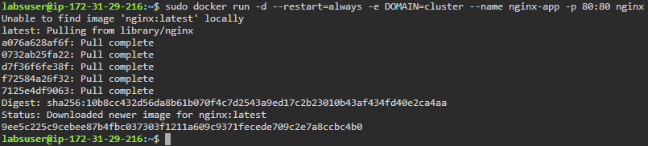

* List the running images to verify the newly installed image

*sudo docker image ls*

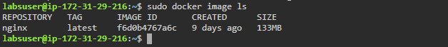

* Check the containers that are running currently

*sudo docker ps*

